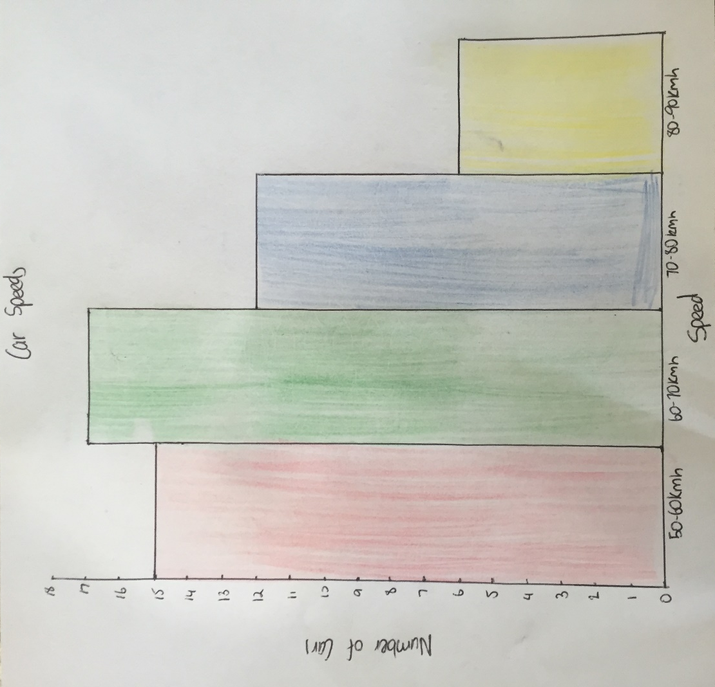
Here is what Problem 3 should look similar to.

